# Screenshots

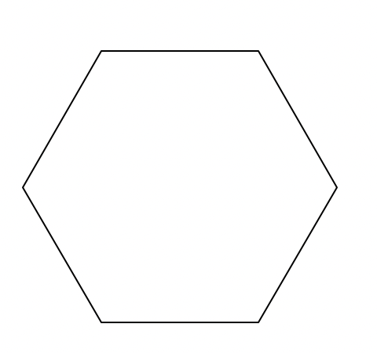

I created a hexagon shape with Python using the turtle forward and right commands in Visual Studio Code!

# Abstract

# Results

# Reflection

# Sources